1. **Use Figma to create an interactive diagram illustrating the components of a basic cellular system.**

**Aim:** -

To create an interactive diagram illustrating the components of a basic cellular system

**Procedure: -**

1. open Figma

2. Create a new file

3. Select the Frames

4. Fill in the content that is required for presentation

5. Design Visual Elements

6. Make it Interactive

7. Add Annotations and Explanations

8. Incorporate Multimedia

9. Storyboard Animation

11. Review and edit the Prototype

12. Save and Share

**Design: -**

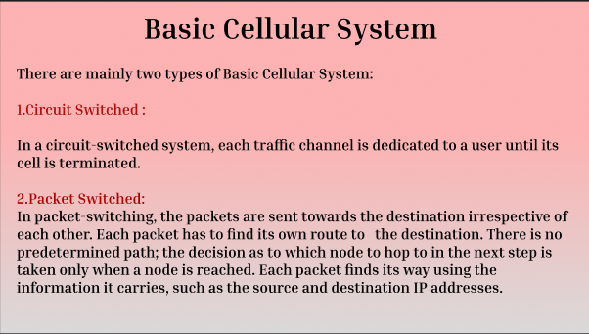 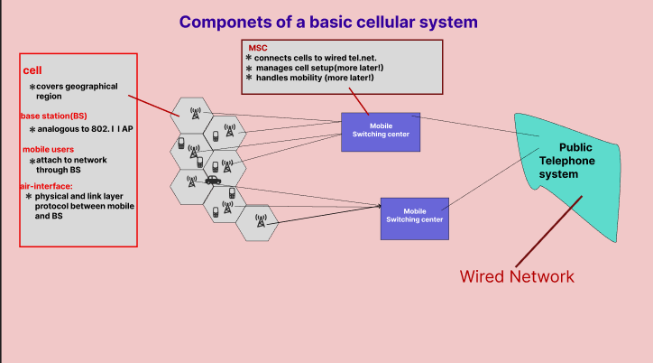 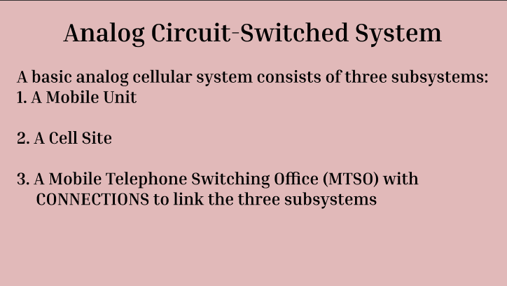 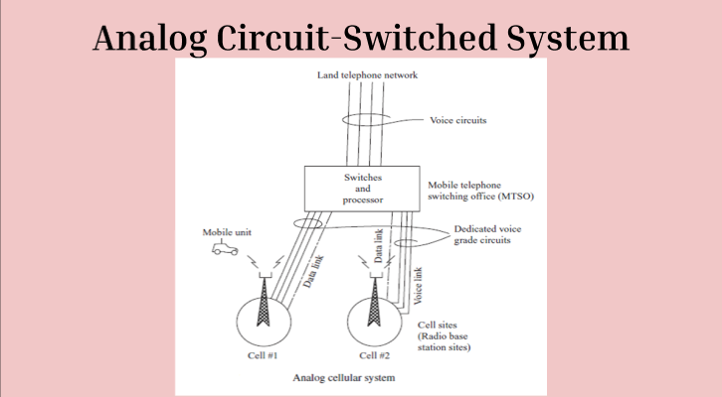

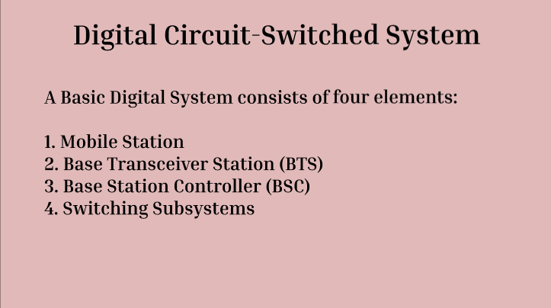 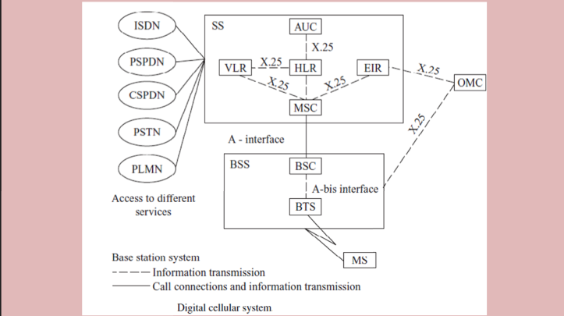

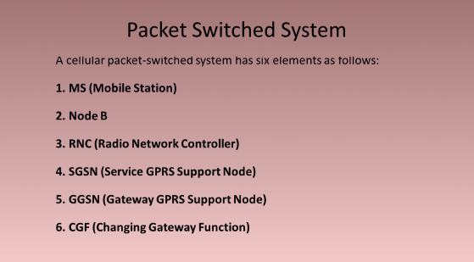 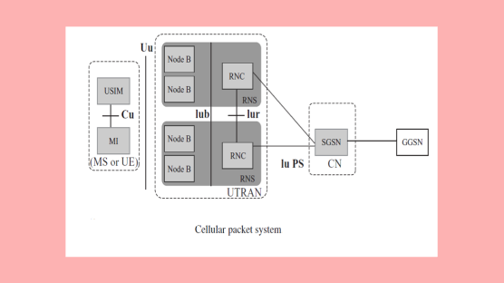

**Prototype: -**

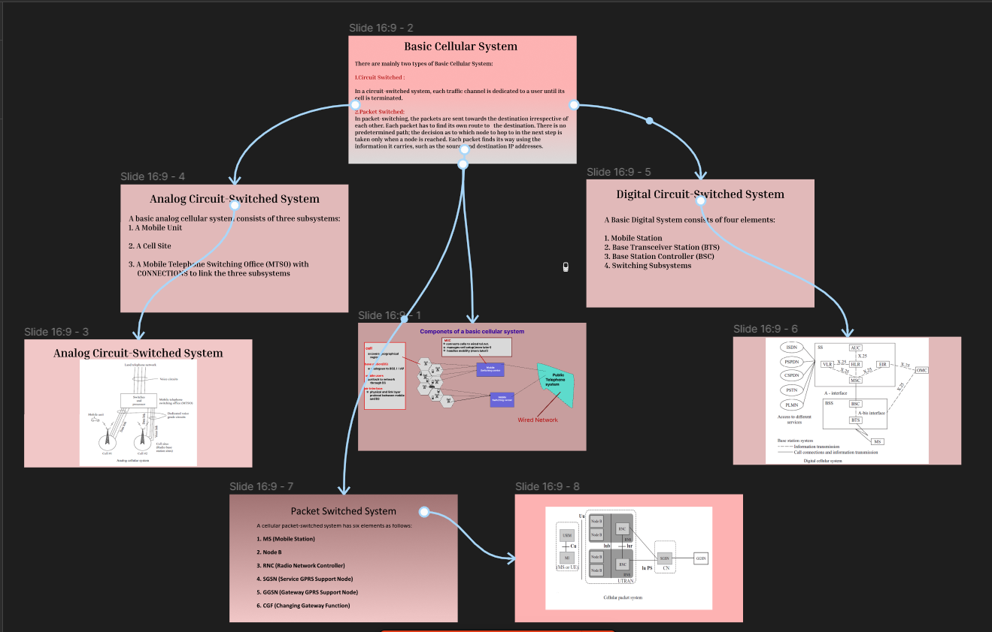

**Result: -**

Hence an interactive diagram illustrating the components of a basic cellular system using

Figma is created and executed successfully

**2.** **Design a user interface prototype for a mobile station using Figma, considering connectivity and convenience.**

**Aim: -**

To create a user interface prototype for a mobile station using Figma, considering connectivity and convenience.

**Procedure: -**

1. open Figma

2. Create a new file

3. Select the Frames

4. Design Visual Elements

5. Make it Interactive

6. Add icons on the Frame

7. Incorporate Multimedia

8. Storyboard Animation

9. Review and edit the Prototype

10. Save and Share

**Design:-**

 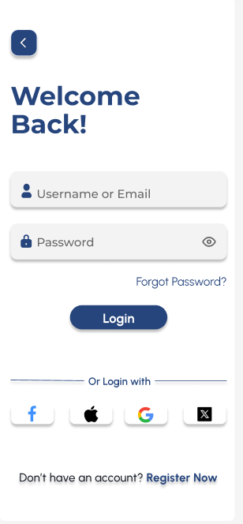 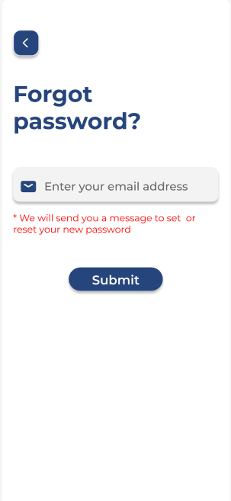 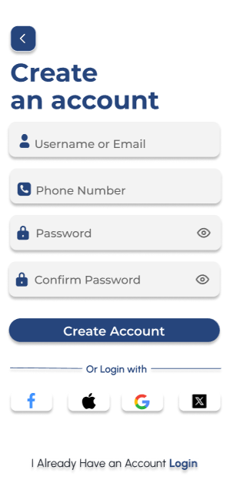 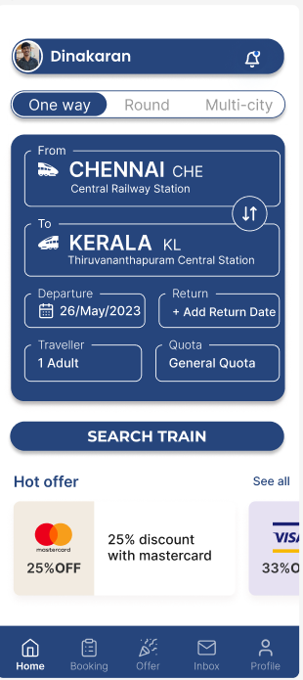

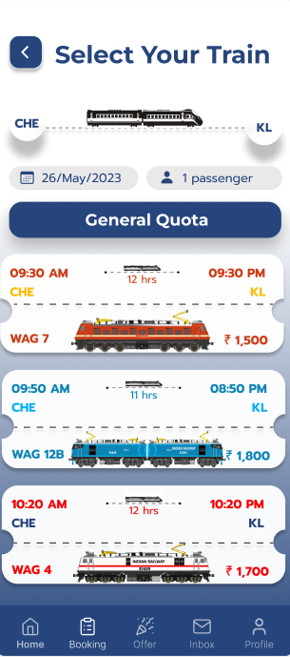 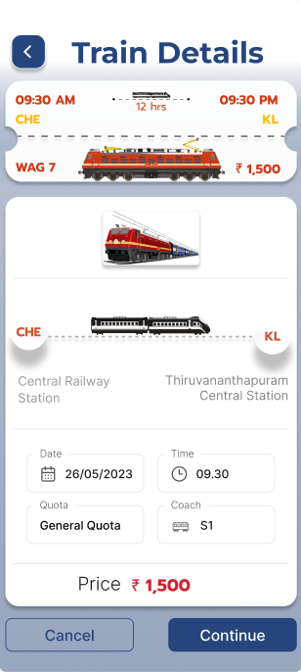 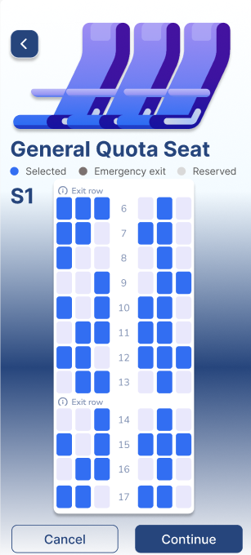 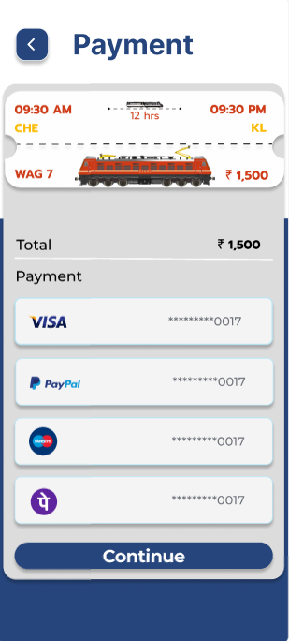 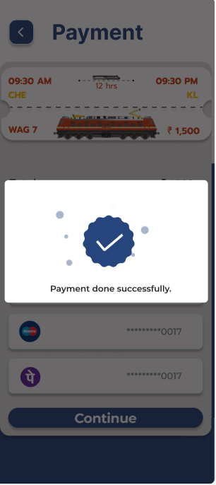

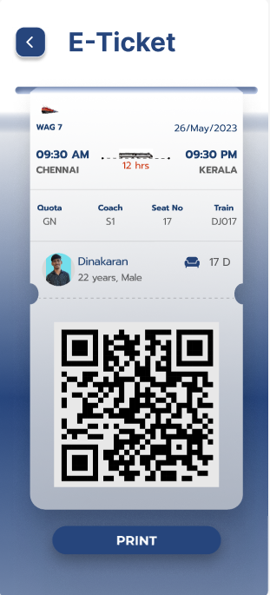 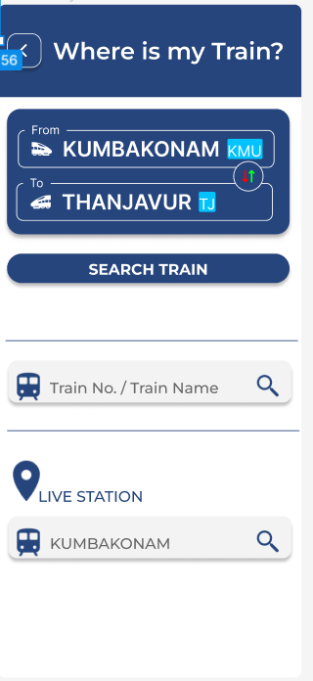 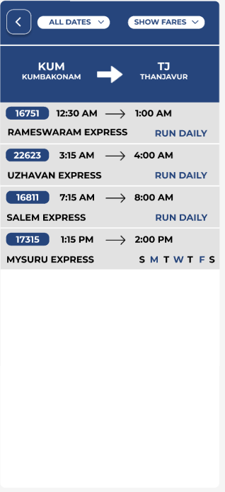 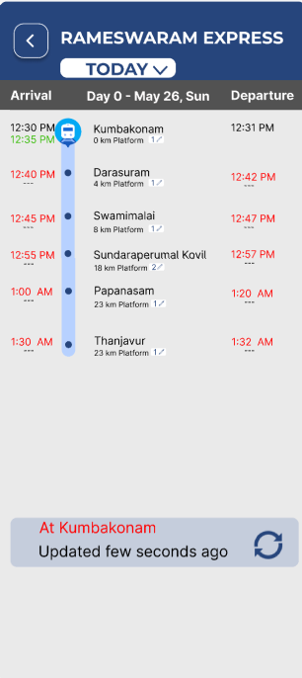

**Prototype: -**

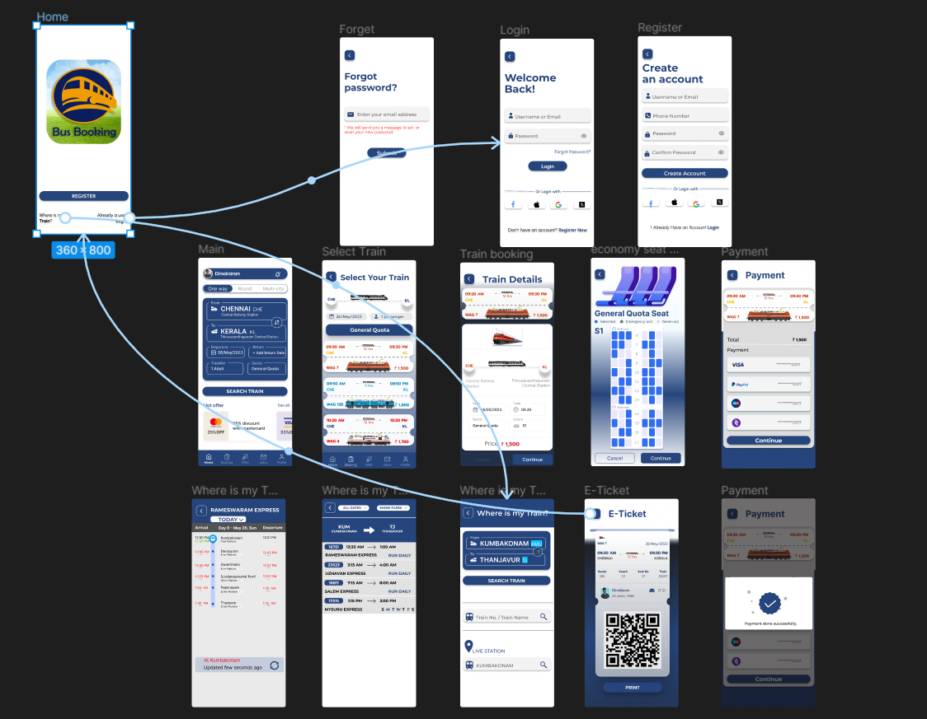

**Result: -**

A user interface prototype for a mobile station using Figma, considering connectivity and convenience using Figma is created and executed successful

**3. Develop a flowchart in Figma depicting the operation of a Network Switching Subsystem in a mobile cellular system.**

**Aim: -**

To draw a flowchart in Figma depicting the operation of a Network Switching Subsystem in a mobile cellular system

**Procedure: -**

1. open Figma

2. Create a new file

3. Click on the resources icon and click on the plugins

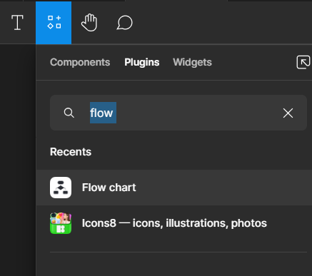

4. Search for the Flow Chart

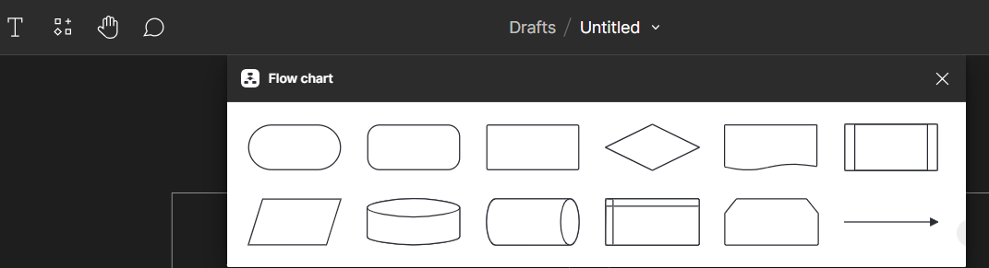

5. Drag and drop the shapes on the screen

6. Now, enter the content on the shapes and connect them through Arrows.

7. Grouping and alignment

8. Review and edit

9. Save and share

**Design: -**

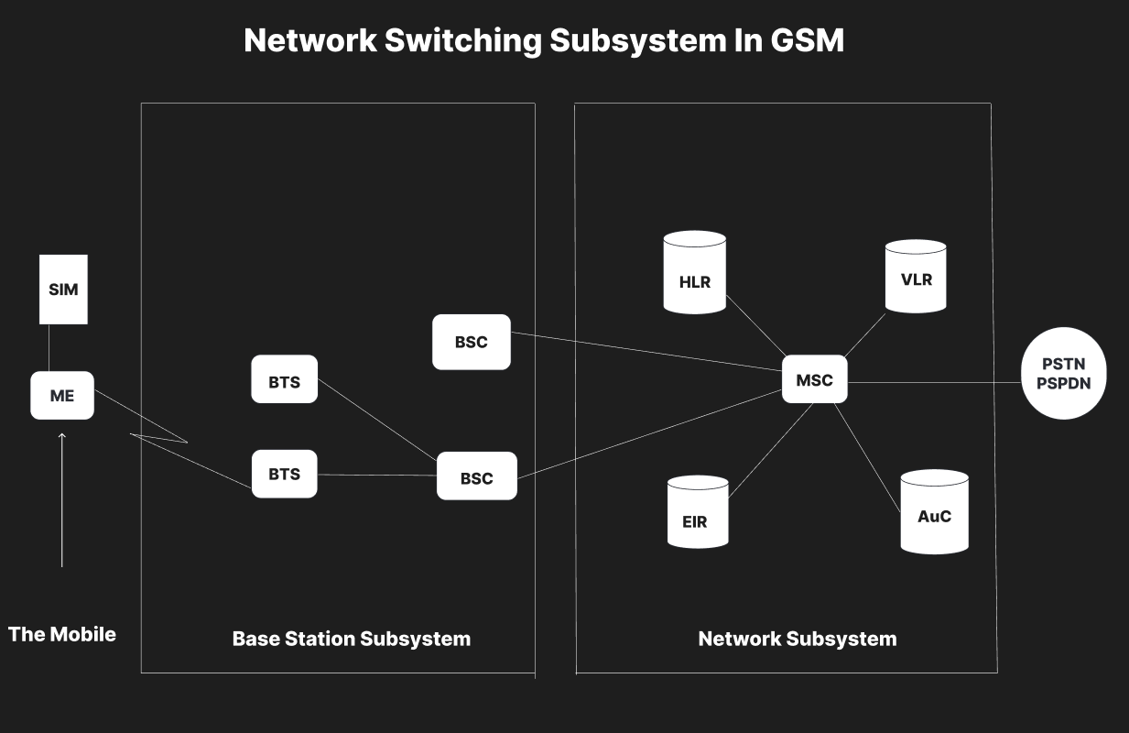

**Result: -**

Hence the flowchart in Figma depicting the operation of a Network Switching Subsystem in a mobile cellular system has been drawn successfully

**4. Create a visual representation in Figma highlighting the key elements of mobile network protocol stacks.**

**Aim: -**

Design a visual representation in Figma highlighting the key elements of mobile network protocol stacks.

**Procedure: -**

1. open Figma

2. Create a new file

3. Select the Frames

4. Fill in the content that is required for presentation

5. Design Visual Elements

6. Make it Interactive

7. Add Annotations and Explanations

8. Incorporate Multimedia

9. Storyboard Animation

11. Review and edit the Prototype

12. Save and Share

**Design: -**

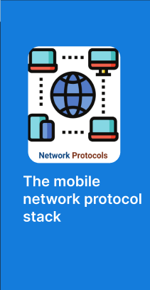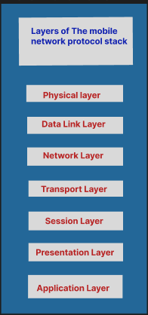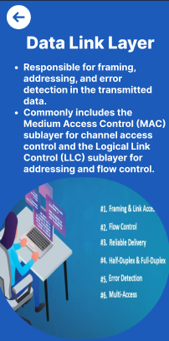

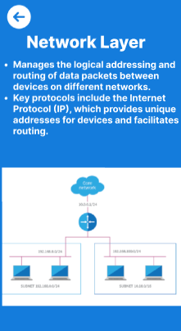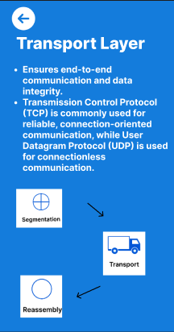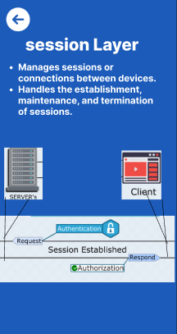

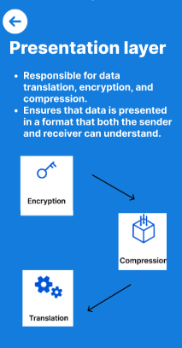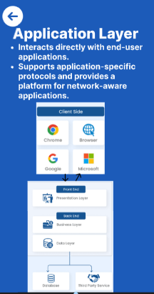

**Prototype: -**

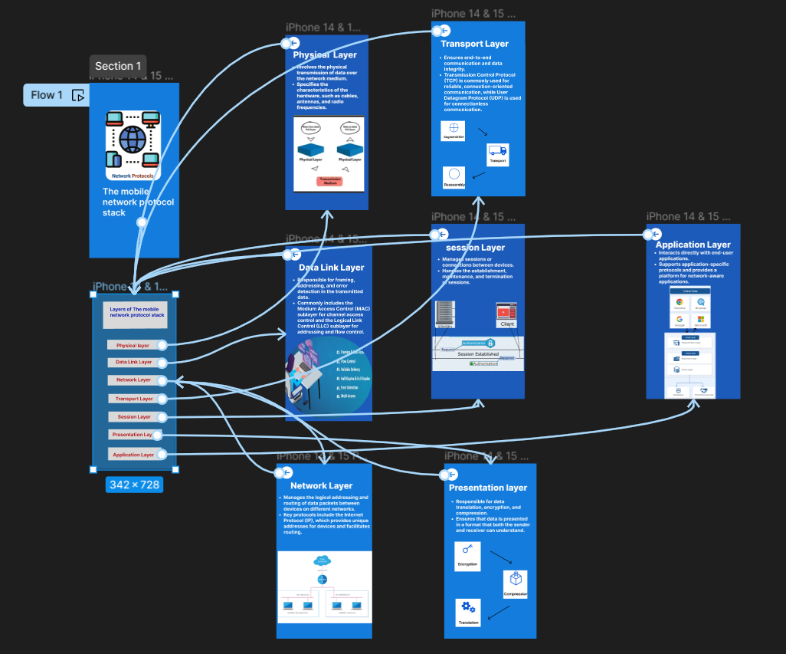

**Result: -**

Hence the visual representation in Figma highlighting the key elements of mobile network protocol stacks is created and executed successfully

**5. Design a wireframe for a mobile application that incorporates localization features using Figma.**

**Aim: -**

To design a wireframe using Figma for a mobile application that incorporates localization features

**Procedure: -**

1. open Figma

2. Create a new file

3. Select the Frames

4. Design Visual Elements

5. Make it Interactive

6. Add icons on the Frame

7. Incorporate Multimedia

8. Storyboard Animation

9. Review and edit the Prototype

10. Save and Share

**Design: -**

  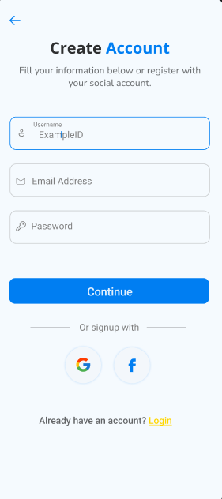 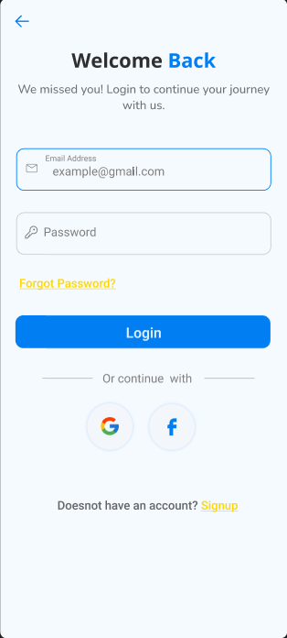 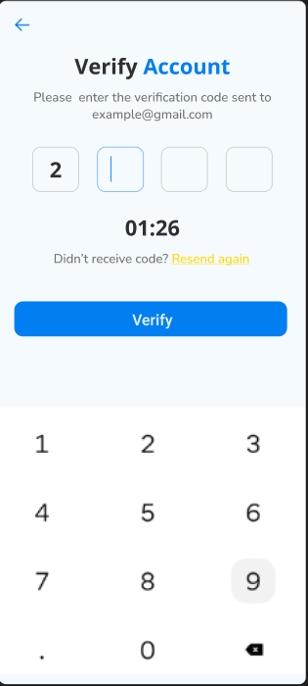 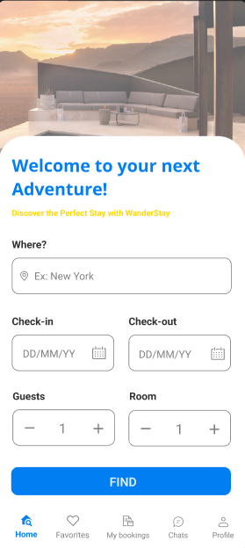

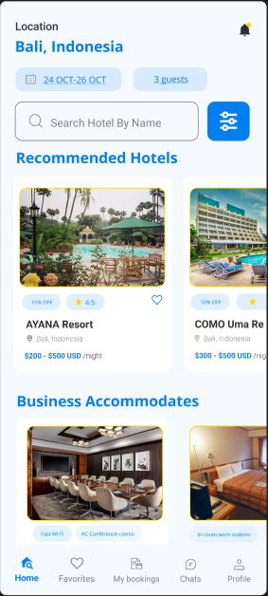 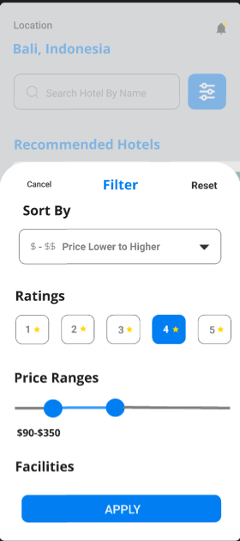 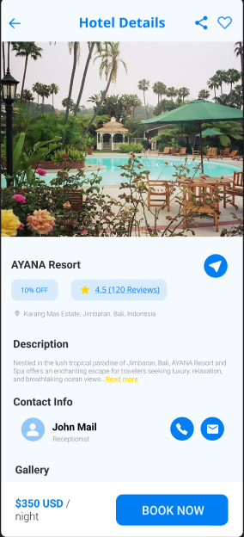 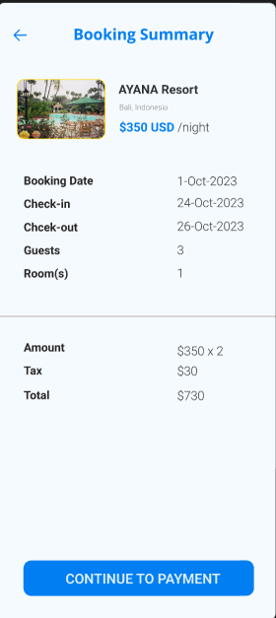 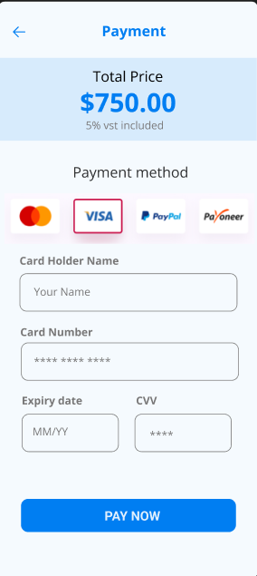 

**Prototype: -**

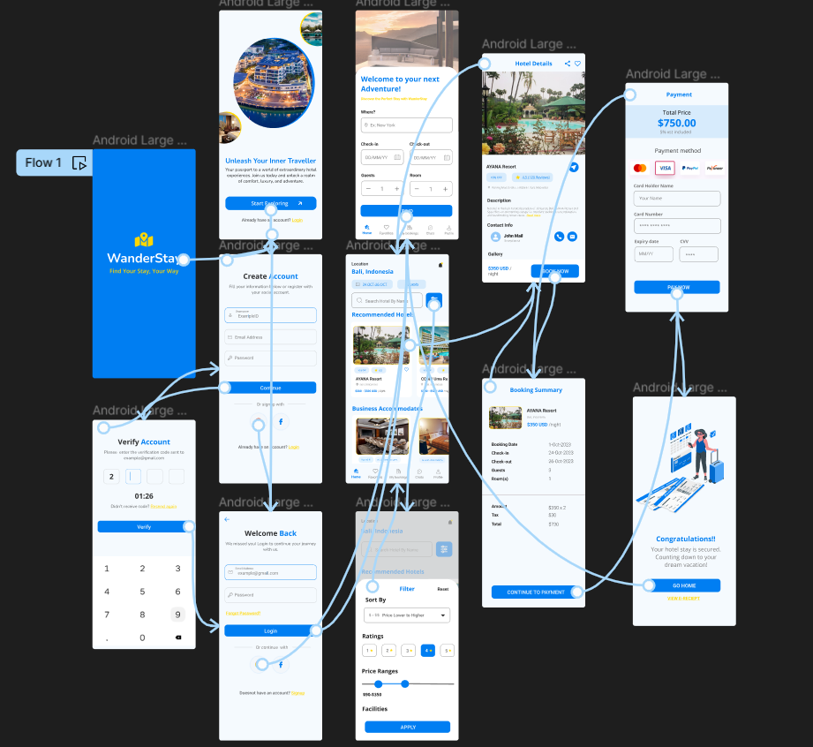

**Result: -**

Hence the wireframe for a mobile application that incorporates localization features using Figma is created and executed successfully

**6. Use Figma to simulate a handoff scenario in a mobile network and visualize the process.**

**Aim: -**To simulate a handoff scenario in a mobile network and visualize the process using Figma.

**Procedure:**

1. Open Figma

2. Create a new file

3. Select the Frames

4. Fill in the content that is required for presentation

5. Design Visual Elements

6. Make it Interactive

7. Add Annotations and Explanations

8. Incorporate Multimedia

9. Storyboard Animation

10. Review and edit the Prototype

11. Save and Share

**Design:**

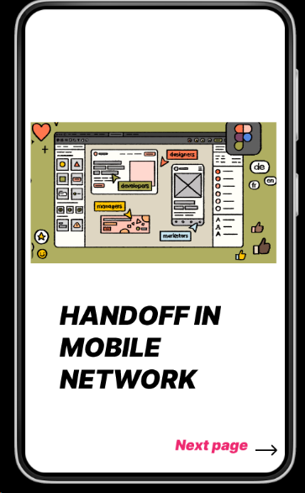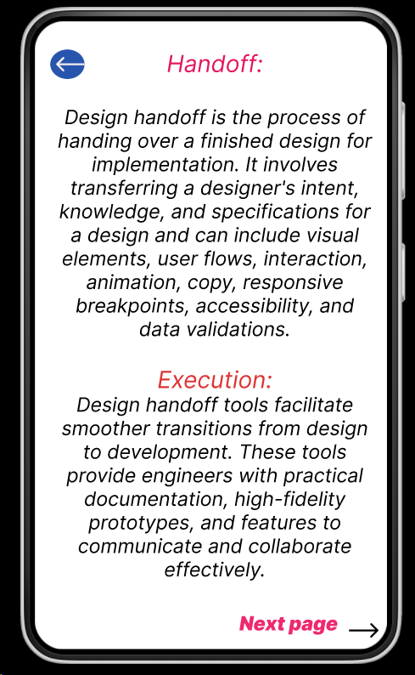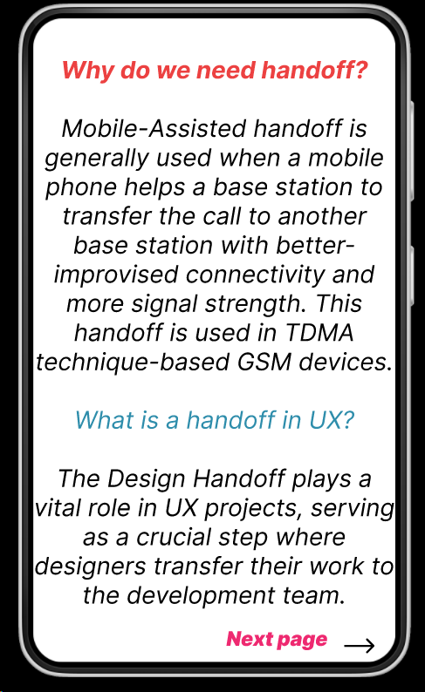

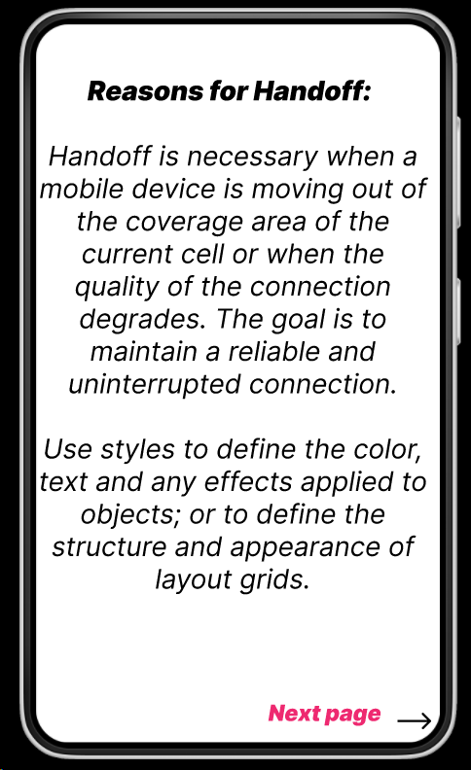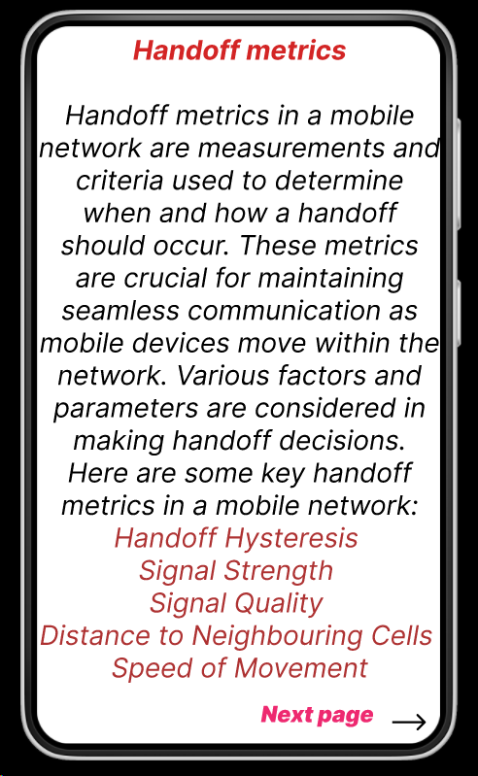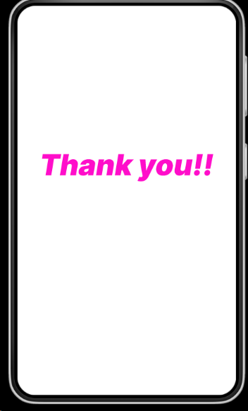

**Prototype:**

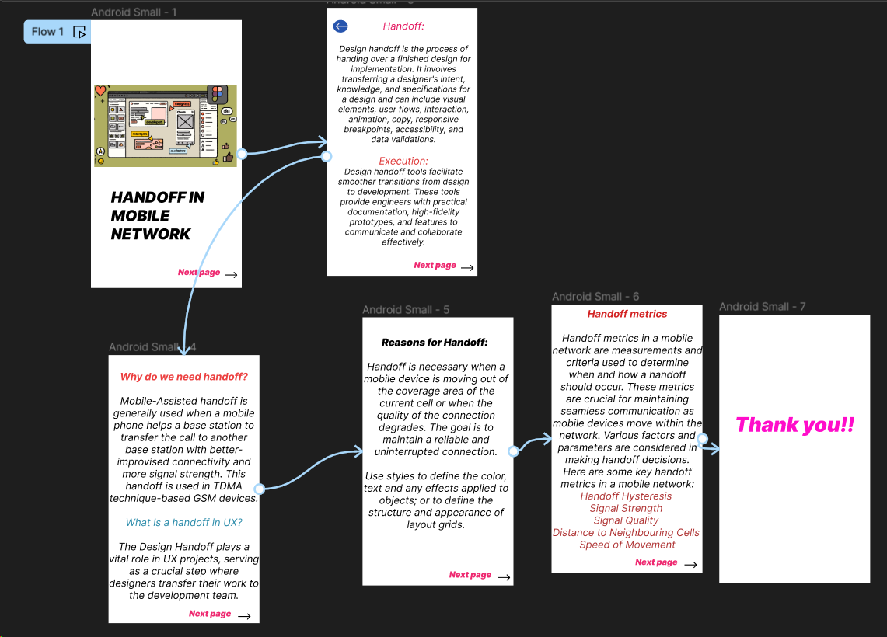

**Result:**

Hence the simulated a handoff scenario in a mobile network and visualized the process using Figma.

**7. Develop a dashboard prototype in Figma displaying performance criteria for a cellular system.**

**Aim:** To develop a dashboard prototype in Figma displaying performance criteria for a cellular system.

**Procedure:**

1. Open Figma

2. Create a new file

3. Select the Frames

4. Fill in the content that is required for presentation

5. Design Visual Elements

6. Make it Interactive

7. Add Annotations and Explanations

8. Incorporate Multimedia

9. Storyboard Animation

10. Review and edit the Prototype

11. Save and Share

**Design:**

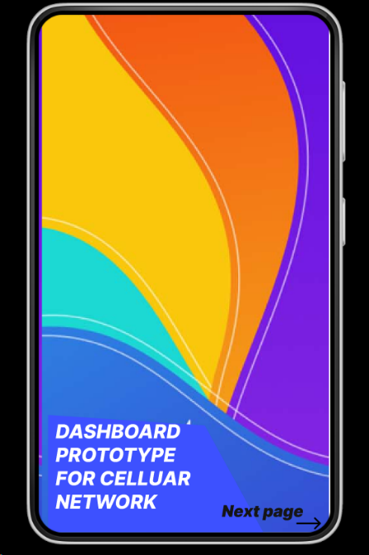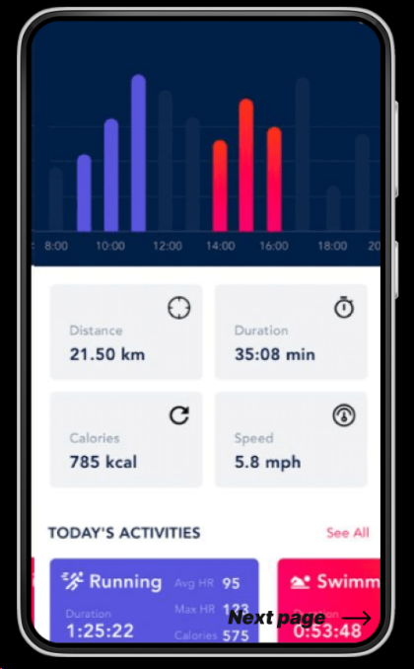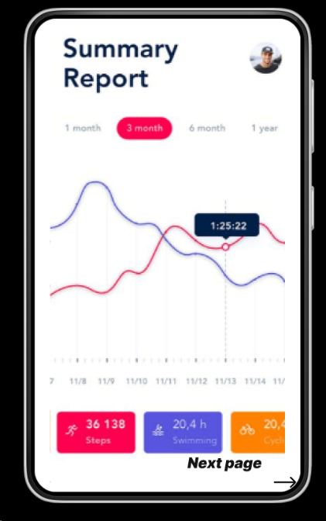

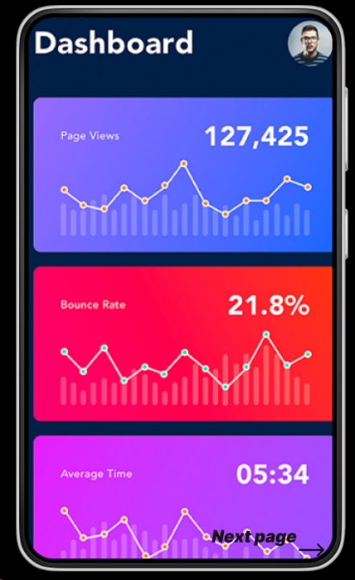 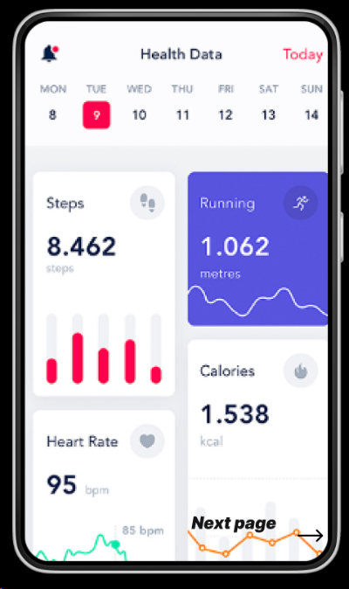

**Prototype:**

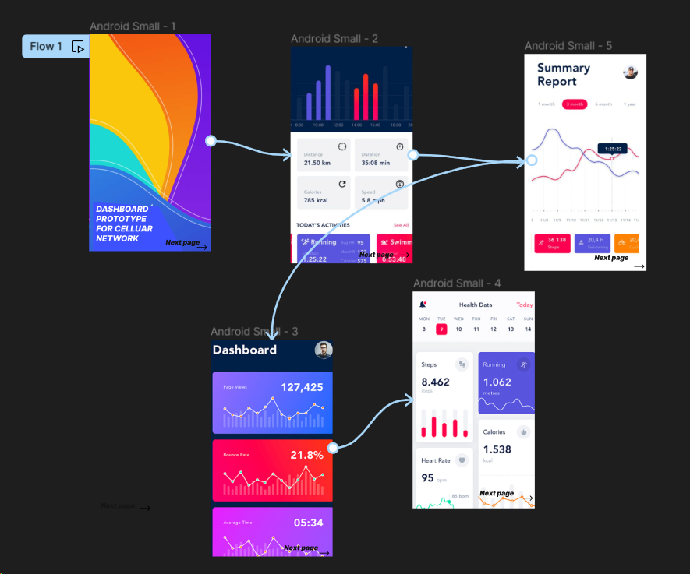

**Result:**

Hence developed a dashboard prototype in Figma displaying performance criteria for a cellular system.

**8. Create an infographic in Figma explaining the concept of Public Land Mobile Network (PLMN).**

**Aim:** To create an infographic in Figma explaining the concept of Public Land Mobile Network (PLMN).

**Procedure:**

1. Open Figma

2. Create a new file

3. Select the Frames

4. Fill in the content that is required for presentation

5. Design Visual Elements

6. Make it Interactive

7. Add Annotations and Explanations

8. Incorporate Multimedia

9. Storyboard Animation

10. Review and edit the Prototype

11. Save and Share

**Design:**

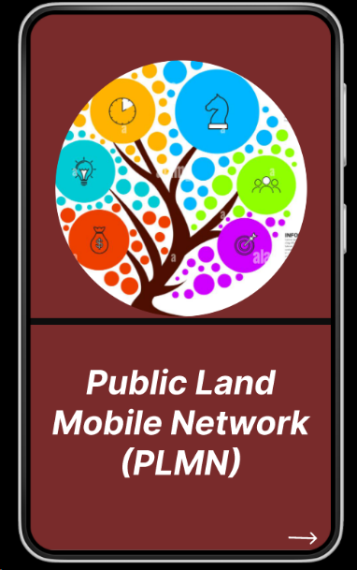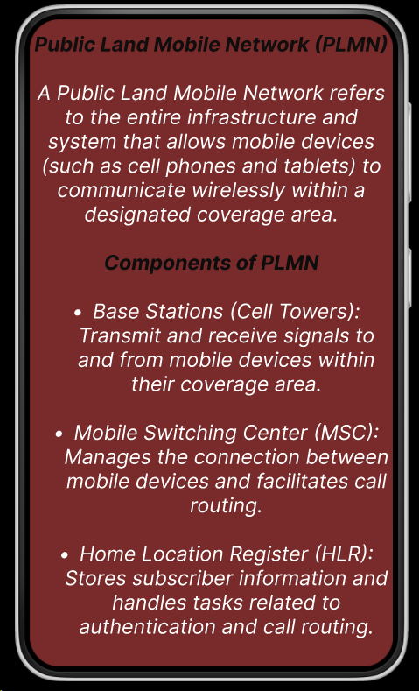

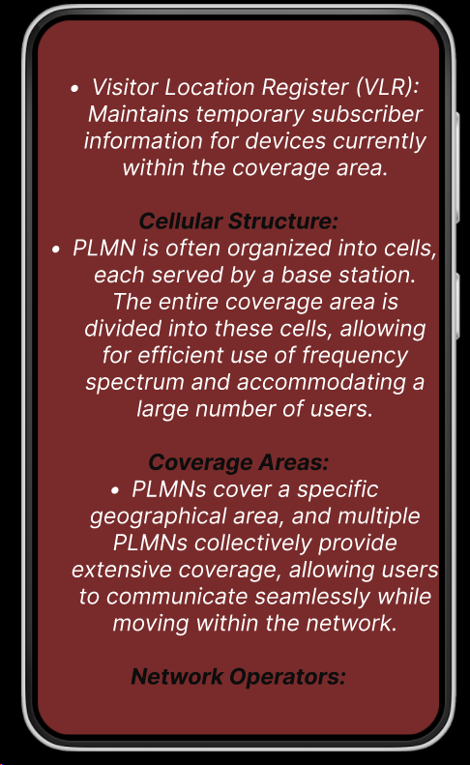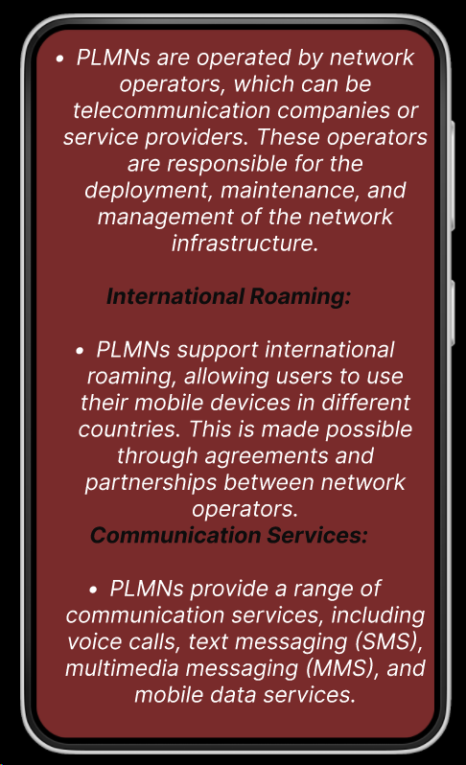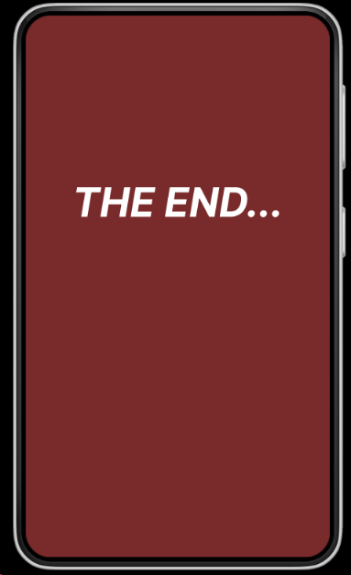

**Prototype:**

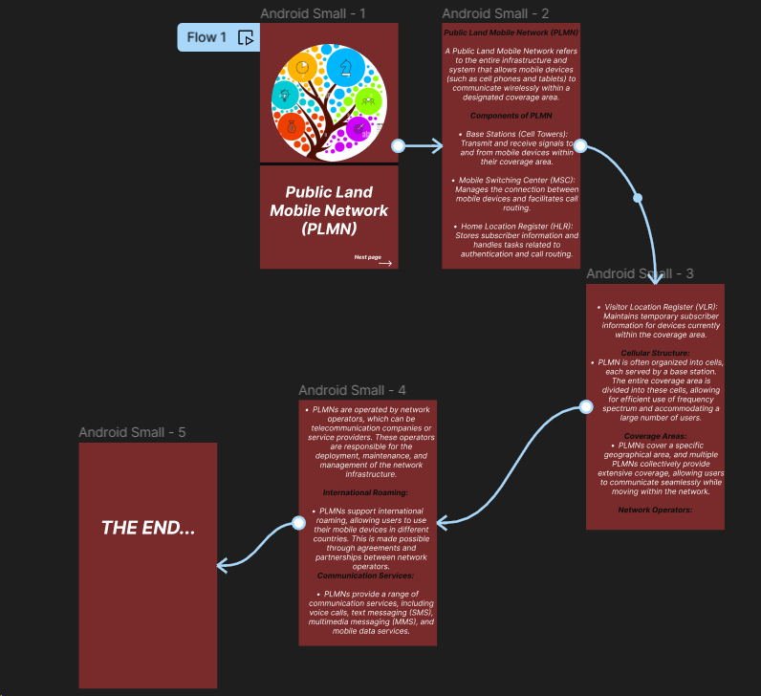

**Result:**

Hence created an infographic in Figma explaining the concept of Public Land Mobile Network (PLMN).

**9. Develop a user interface prototype for a GSM service using Figma.**

**Aim:** To develop a user interface prototype for a GSM service using Figma.

**Procedure:**

1. Open Figma

2. Create a new file

3. Select the Frames

4. Fill in the content that is required for presentation

5. Design Visual Elements

6. Make it Interactive

7. Add Annotations and Explanations

8. Incorporate Multimedia

9. Storyboard Animation

10. Review and edit the Prototype

11. Save and Share

**Design:**

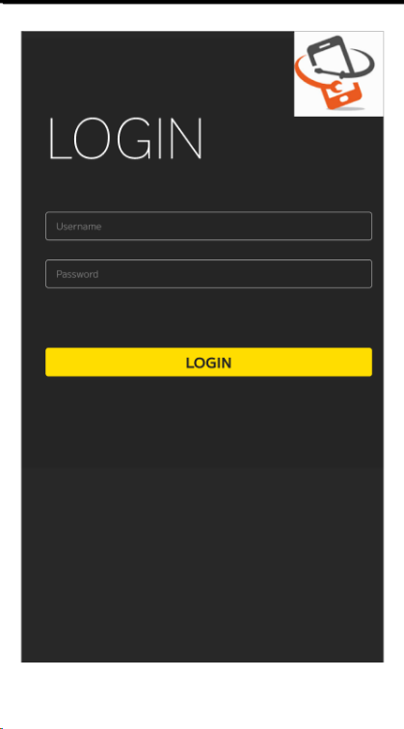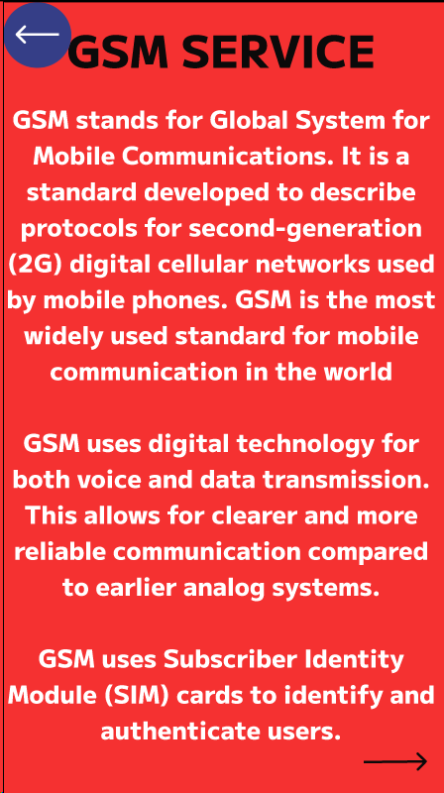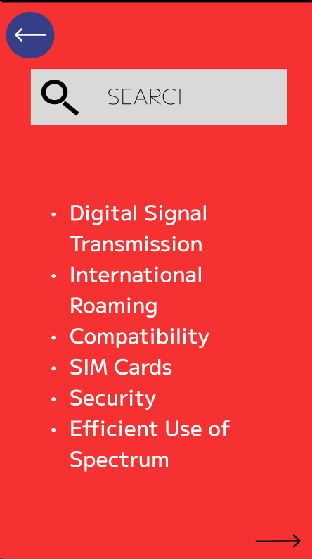

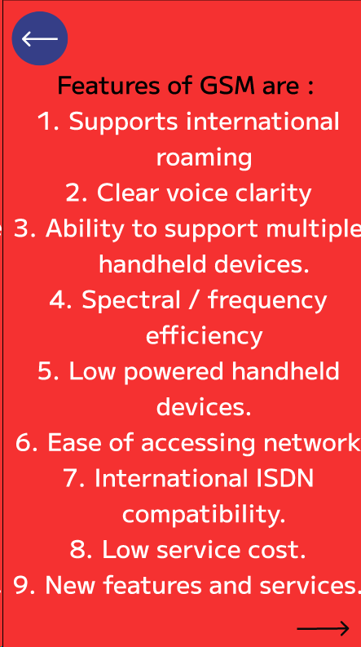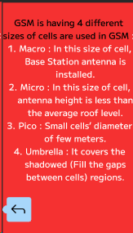

**Prototype:**

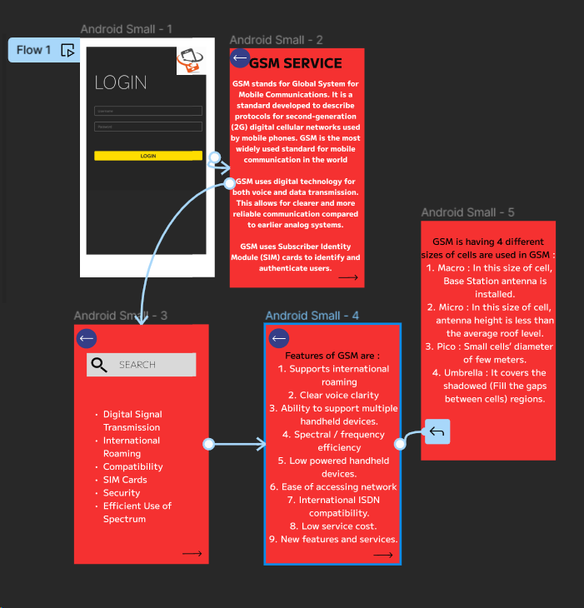

**Result:**

Hence developed a user interface prototype for a GSM service using Figma.

**10. Create a visual representation in Figma showcasing the differences between various multiple access techniques.**

**Aim:** To create a visual representation in Figma showcasing the differences between various multiple access techniques.

**Procedure:**

1. Open Figma

2. Create a new file

3. Select the Frames

4. Fill in the content that is required for presentation

5. Design Visual Elements

6. Make it Interactive

7. Add Annotations and Explanations

8. Incorporate Multimedia

9. Storyboard Animation

10. Review and edit the Prototype

11. Save and Share

**Design:**

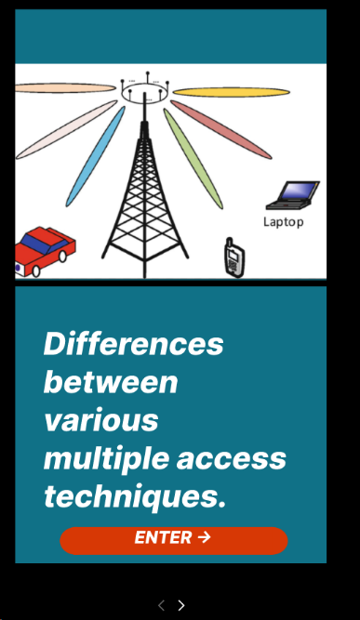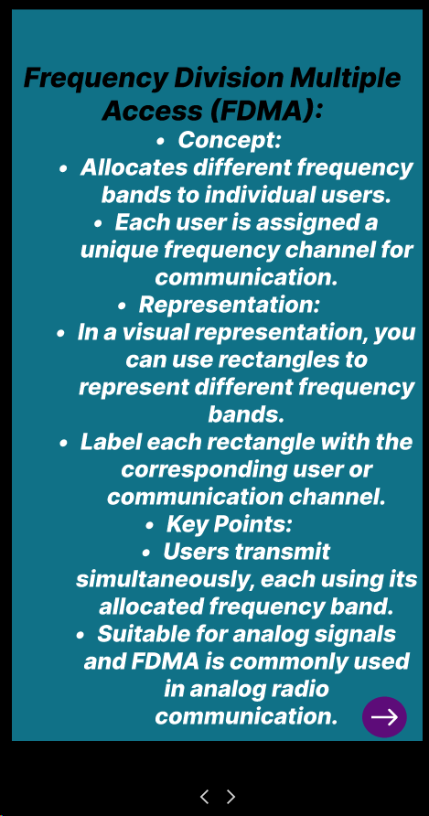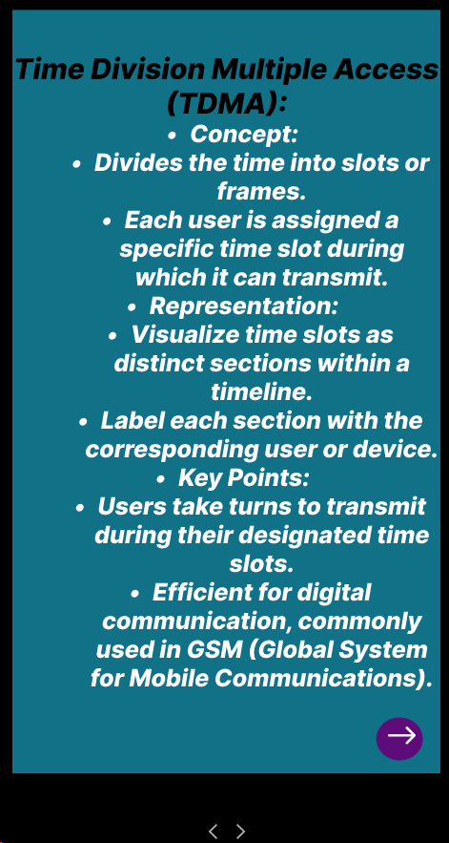

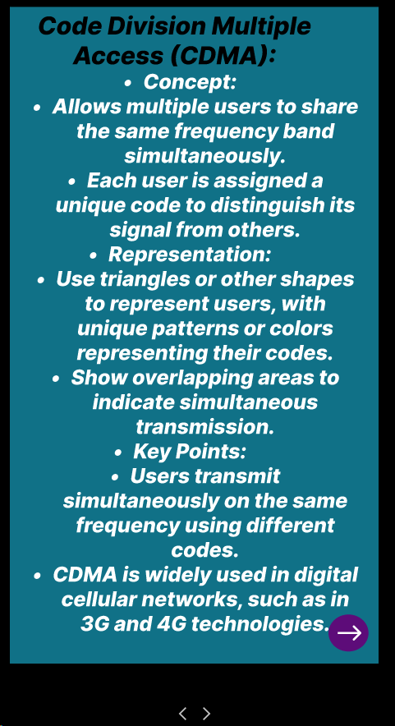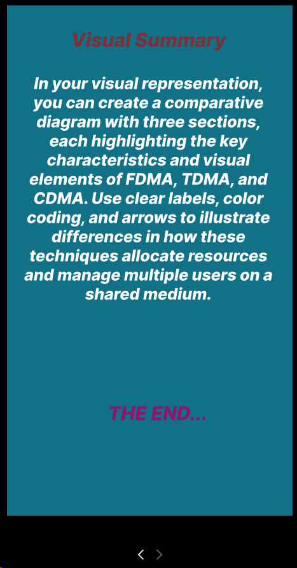

**Prototype:**

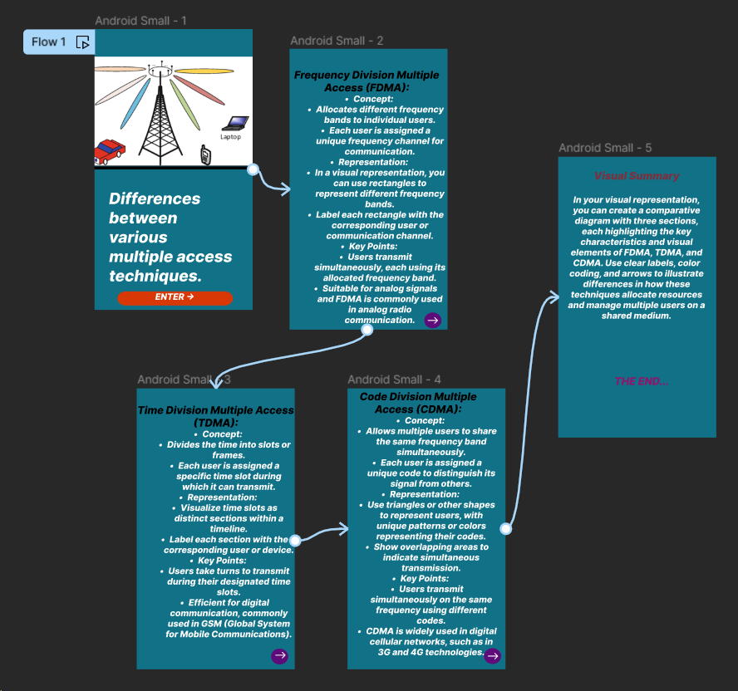

**Result:**

Hence created a visual representation in Figma showcasing the differences between various multiple access techniques.

**11**. **Design a wireframe for a mobile application that incorporates security measures using Figma.**

**Aim: -**

Using Figma design a wireframe for a mobile application (Bank app UI) that incorporates security measures.

**Procedure: -**

1. open Figma

2. Create a new file

3. Select the Frames

4. Design Visual Elements

5. Make it Interactive

6. Add icons on the Frame

7. Incorporate Multimedia

8. Storyboard Animation

9. Review and edit the Prototype

10. Save and Share

**Design: -**

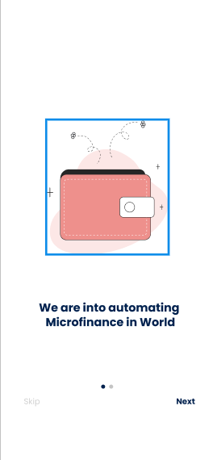     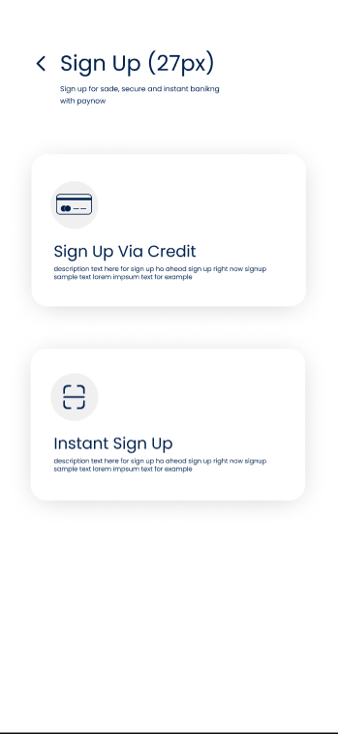 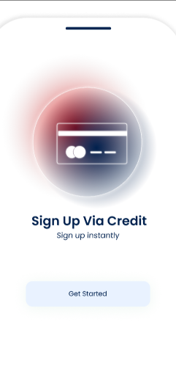 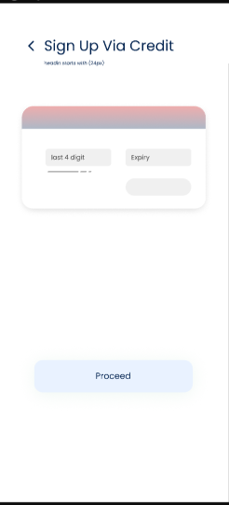 

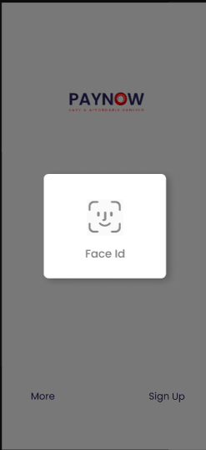 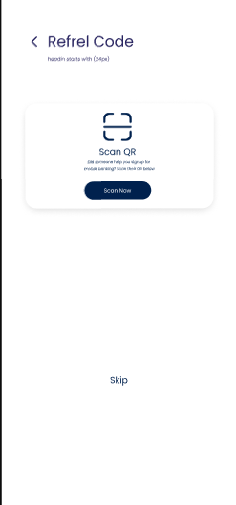 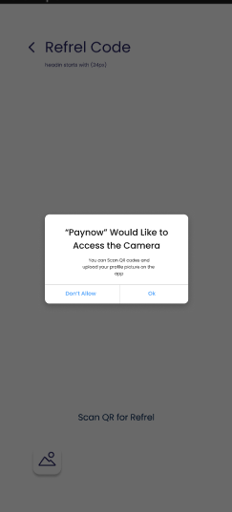 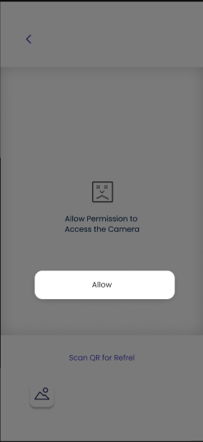 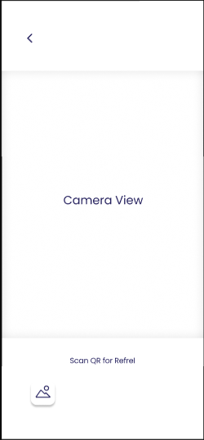  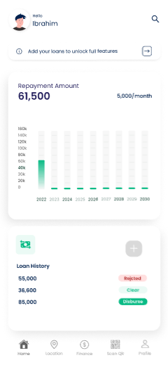 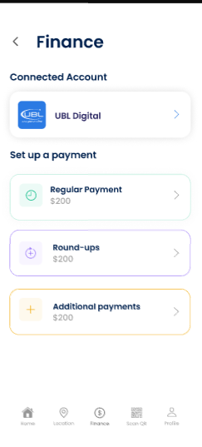 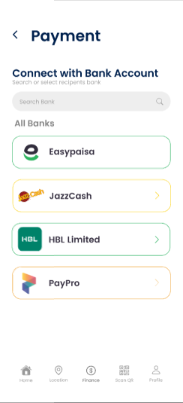

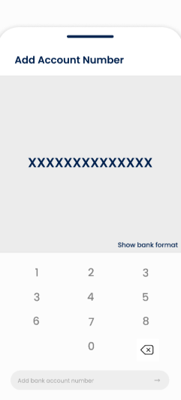 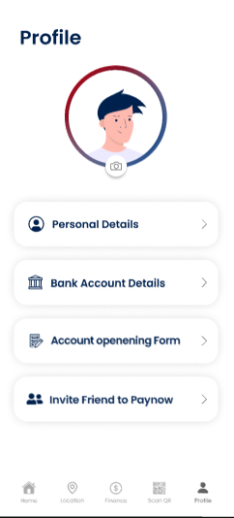 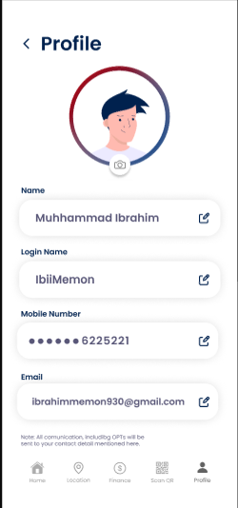 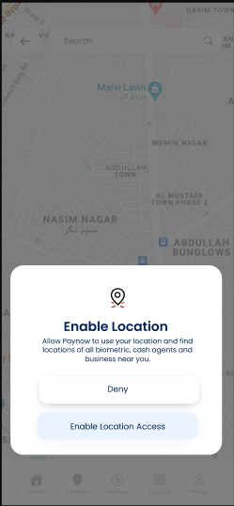 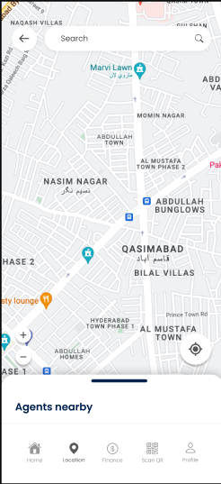 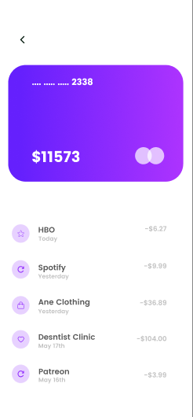 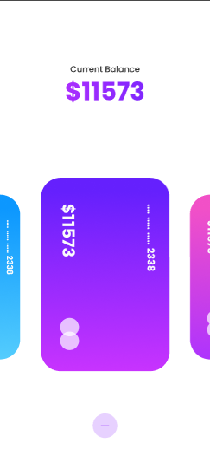

Prototype: -

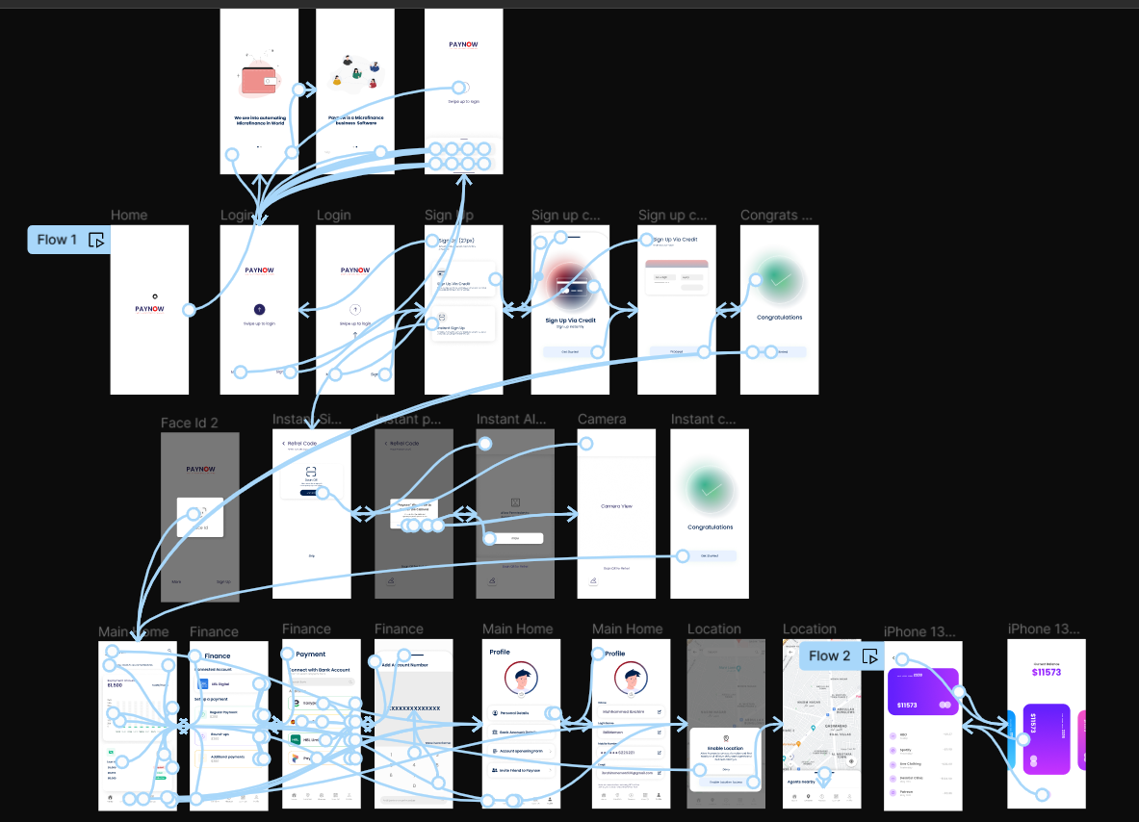

Result: -

A wireframe for a mobile application that incorporates security measures using Figma is created and executed successfully

**12. Use Figma to create an interactive diagram illustrating the evolution from 1G to 5G.**

**Aim: -**

Design an interactive diagram illustrating the evolution from 1G to 5G using Figma.

**Procedure: -**

1. open Figma

2. Create a new file

3. Select the Frames

4. Fill in the content that is required for presentation

5. Design Visual Elements

6. Make it Interactive

7. Add Annotations and Explanations

8. Incorporate Multimedia

9. Storyboard Animation

11. Review and edit the Prototype

12. Save and Share

**Design: -**

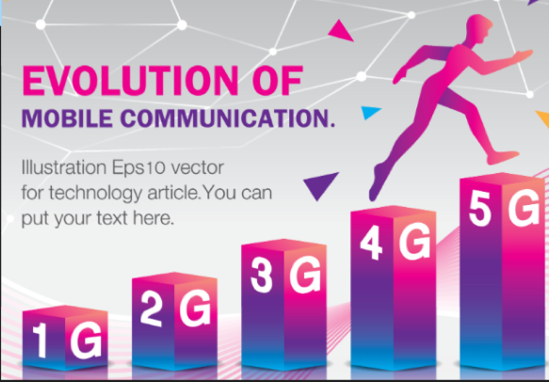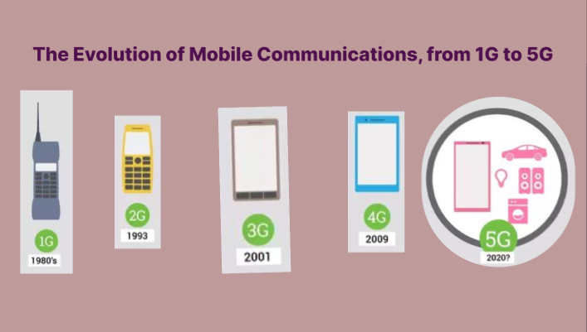

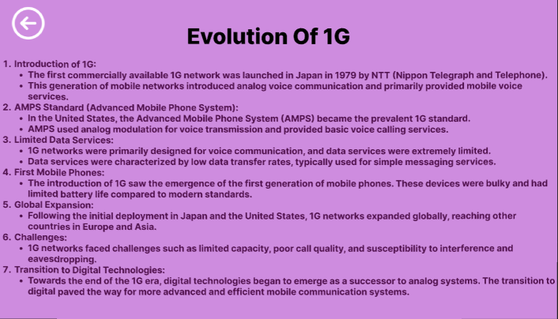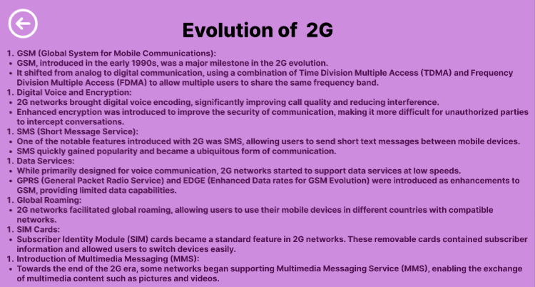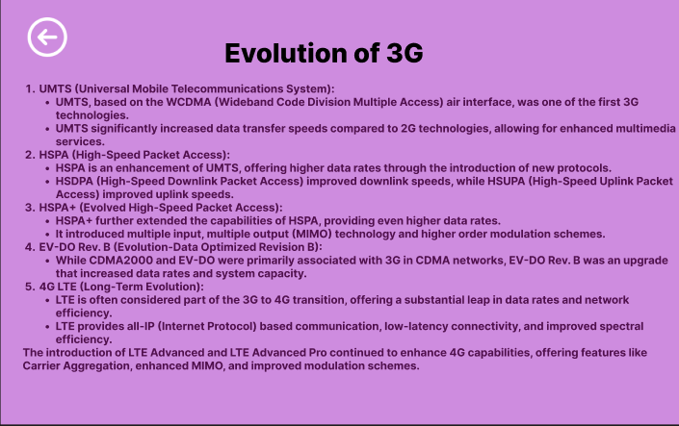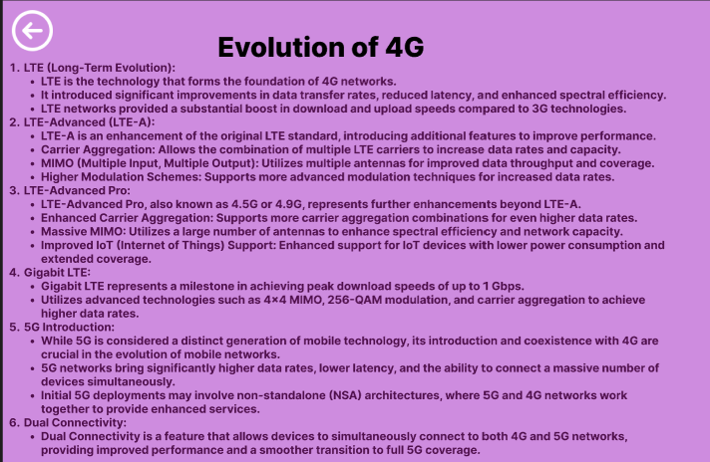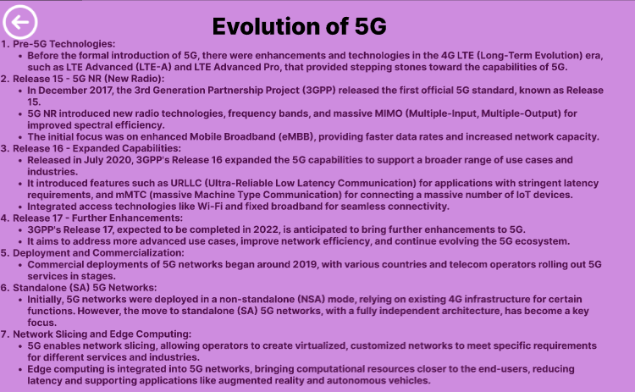

**Prototype: -**

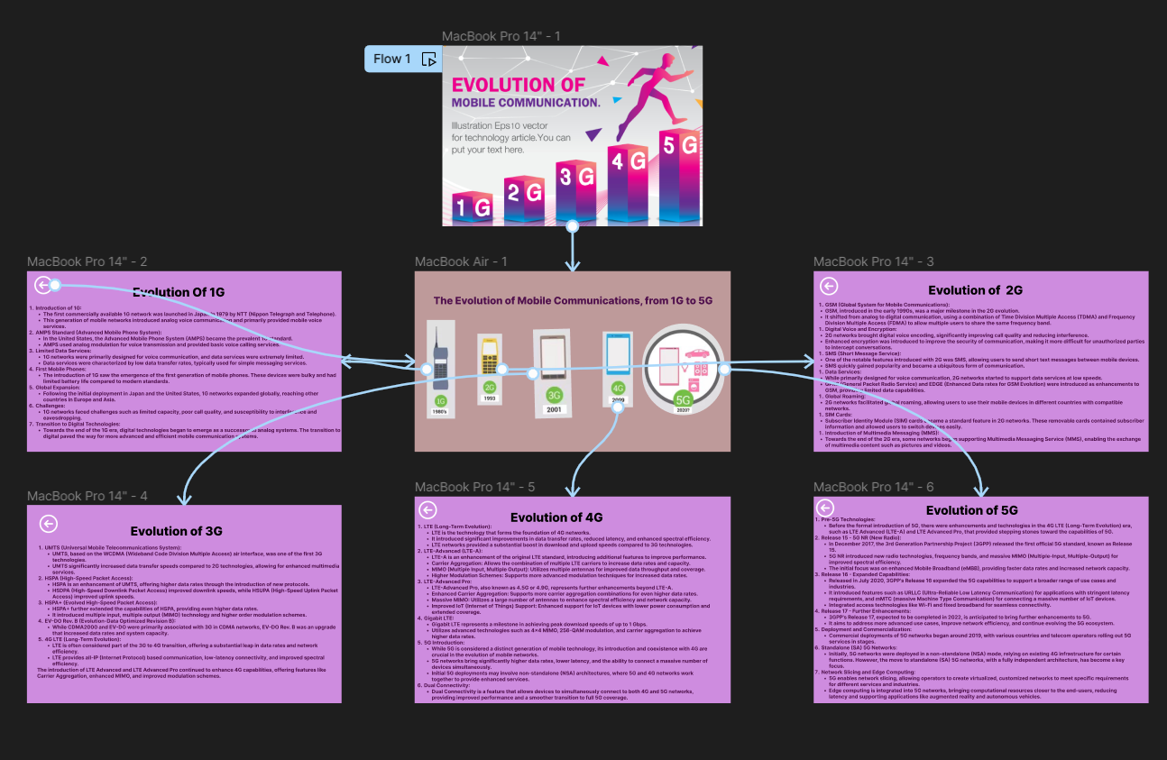

**Result: -**

Hence an interactive diagram illustrating the evolution from 1G to 5G in Figma is created and executed successfully

**13.** **Design an infographic in Figma comparing mobile communication and mobile computing**

**Aim: -**

Using Figma design an infographic comparing mobile communication and mobile computing

**Procedure: -**

1. open Figma

2. Create a new file

3. Select the Frames

4. Fill in the content that is required for presentation

5. Design Visual Elements

6. Make it Interactive

7. Add Annotations and Explanations

8. Incorporate Multimedia

9. Storyboard Animation

11. Review and edit the Prototype

12. Save and Share

**Design: -**

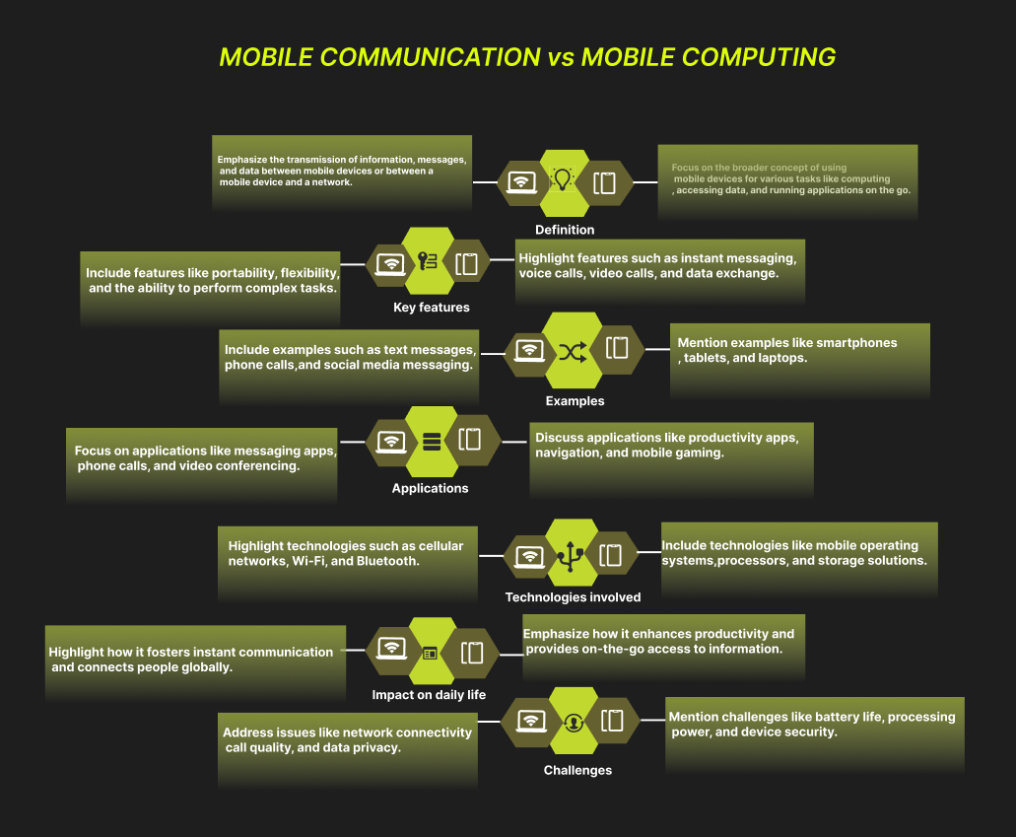

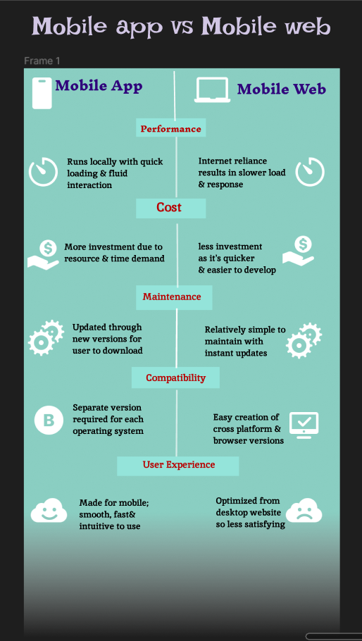

**Result: -**

An infographic design in Figma comparing mobile communication and mobile computing is created successfully.

**14. Develop a flowchart in Figma explaining the operation of General Packet Radio Service (GPRS).**

**Aim: -**

Draw a flowchart in Figma explaining the operation of General Packet Radio Service (GPRS).

**Procedure: -**

1. open Figma

2. Create a new file

3. Click on the resources icon and click on the plugins



4. Search for the Flow Chart



5. Drag and drop the shapes on the screen

6. Now, enter the content on the shapes and connect them through Arrows.

7. Grouping and alignment

8. Review and edit

9. Save and share

**Design: -**

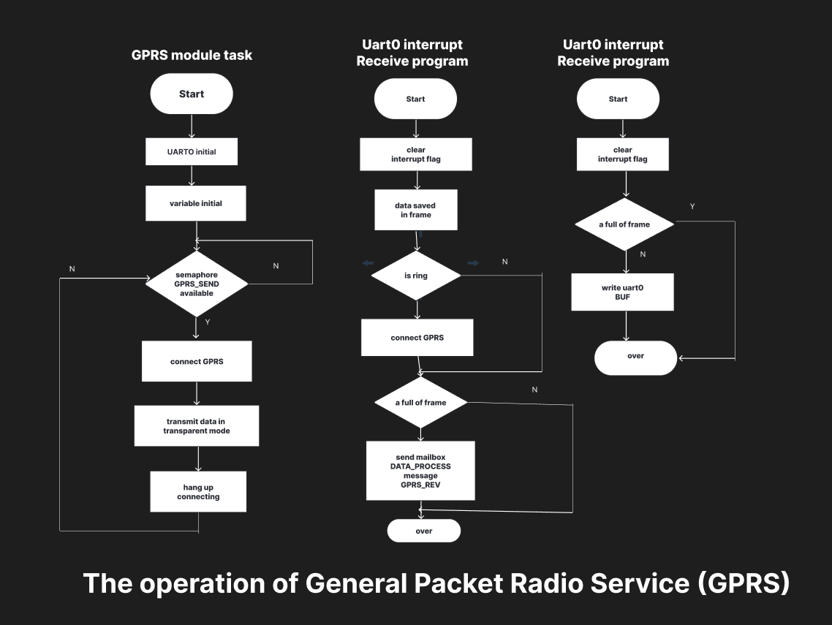

**Result: -**

**Hence the flowchart in Figma explaining the operation of General Packet Radio Service (GPRS) has been drawn successfully.**

**16. Develop a wireframe for a mobile application that addresses challenges related to ad hoc wireless networks using Figma.**

**Aim: -**

Create a Wireframe for a mobile application that addresses challenges related to ad hoc wireless networks using Figma.

**Procedure: -**

1. open Figma

2. Create a new file

3. Select the Frames

4. Design Visual Elements

5. Make it Interactive

6. Add icons on the Frame

7. Incorporate Multimedia

8. Storyboard Animation

9. Review and edit the Prototype

10. Save and Share

**Design: -**

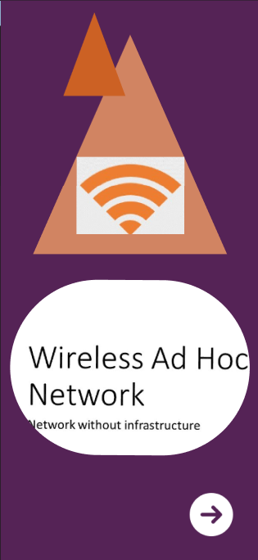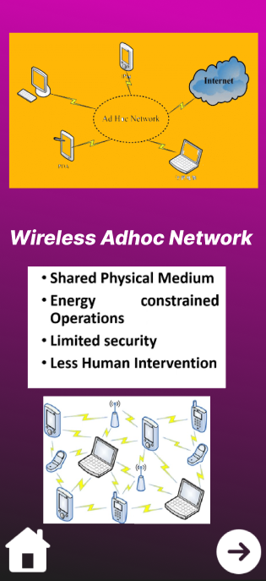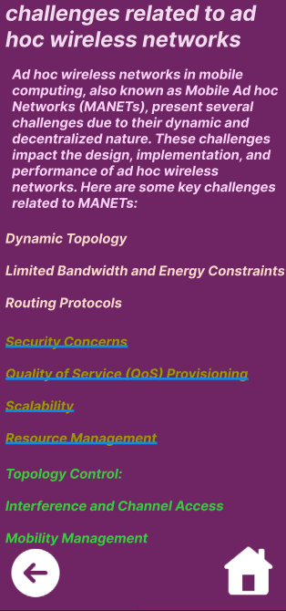

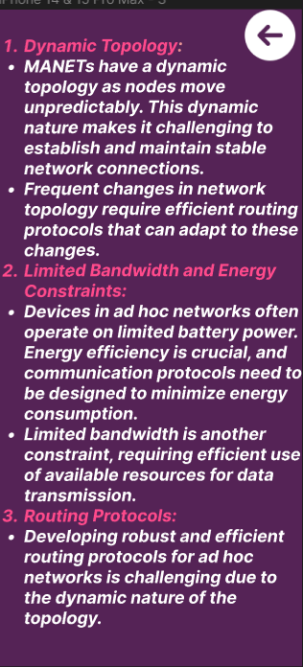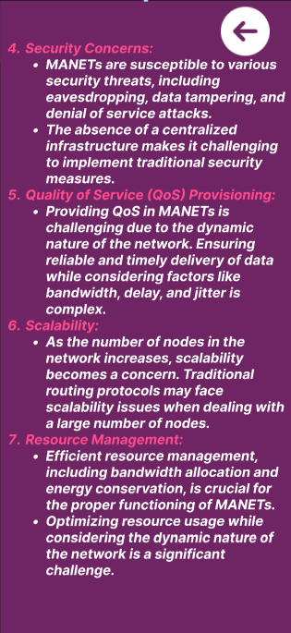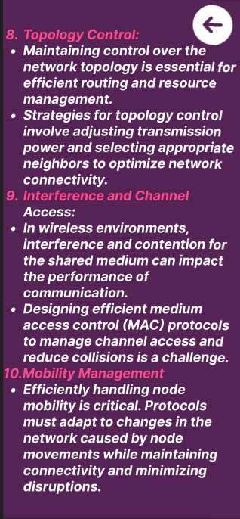

**Prototype: -**

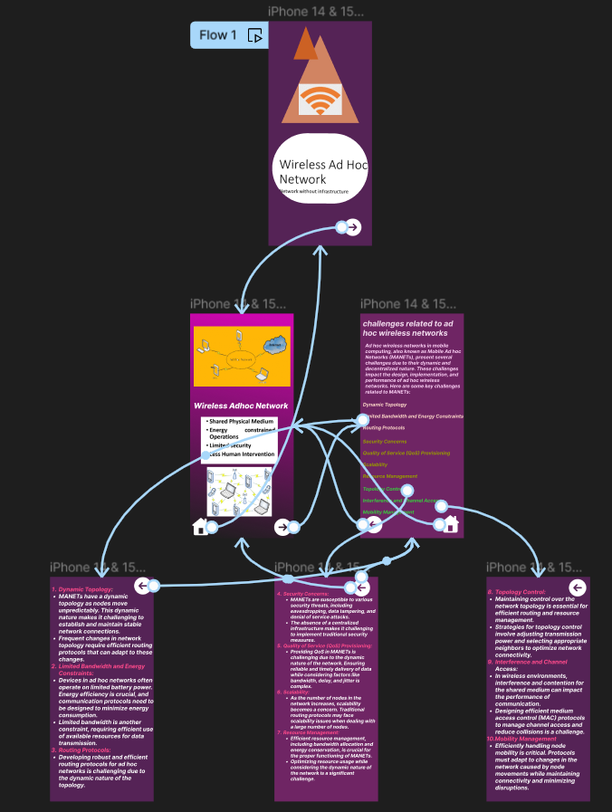

**Result: -**

Hence a wireframe for a mobile application that addresses challenges related to ad hoc wireless networks using Figma is created and executed successfully